成功國小100學年度英語 第一次試題測驗U1 六年 號姓名

ㄧ、聽力測驗：
1.（Track 7）
(1) ( )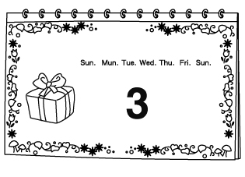( )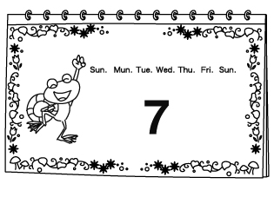
(2) ( )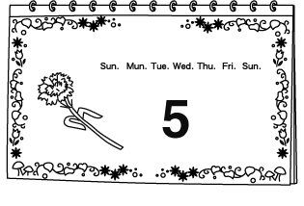( )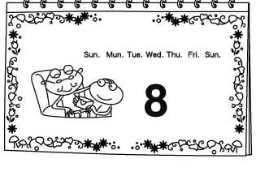
(3) ( )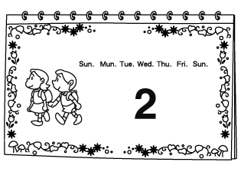( )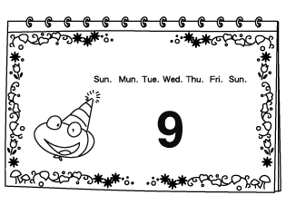
(4) ( )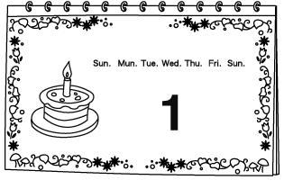( )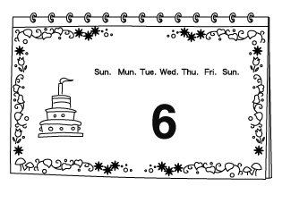

2.Listen and Check 聽 CD，勾選正確的單字圖片：
- （Track 2）
(1) ( ) 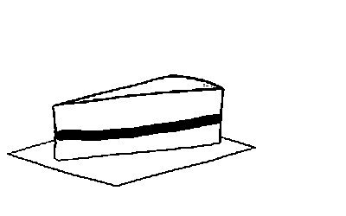 ( ) 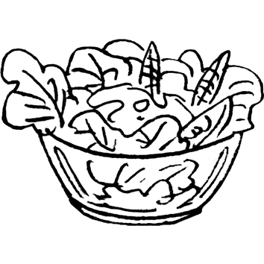
(2) ( ) 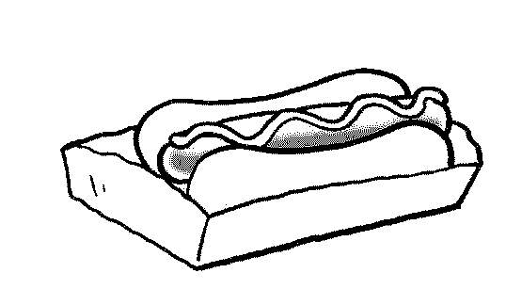( ) 
(3) ( )  ( ) 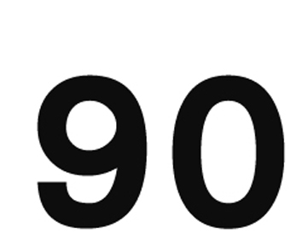
(4) ( ) ( ) 

3.Listen and Number 聽 CD，將圖片依序標號：
- （Track 4）
( ) 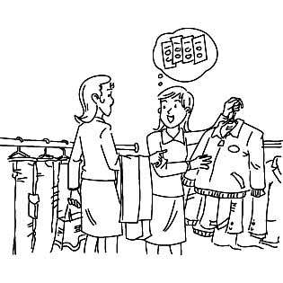 ( ) 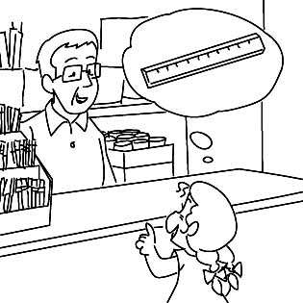
( ) 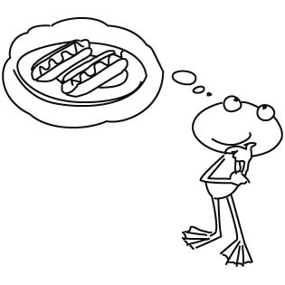 ( ) 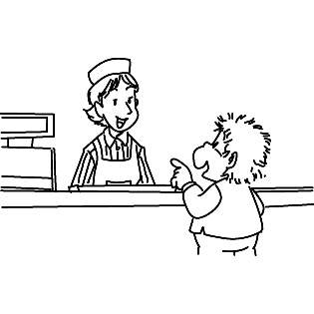

二、Look and Choose 看圖選出正確的句子：
- ( )
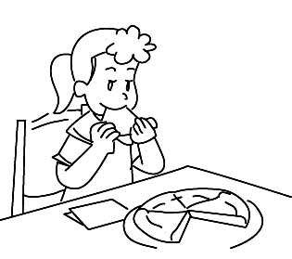
A: ＿＿＿＿＿＿
B: Pizza.
(1) What does he like to eat?
(2) What do you like to eat, Lisa?
(3) What does she like to do?
(4) Whose pizza is it?
- ( )
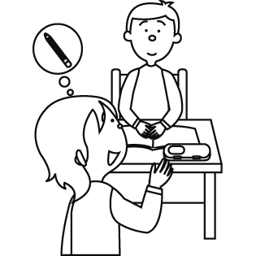
(1) I’m sorry. I don’t have one.
(2) Never mind.
(3) Find six red pens.
(4) May I have a pencil?
- ( )
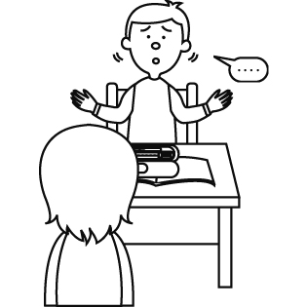
(1) Never mind.
(2) Please pay attention.
(3) I’m sorry. I don’t have one.
(4) Well done!
- ( )
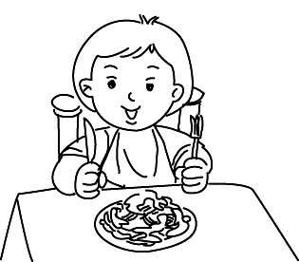
A: ＿＿＿＿＿＿
B: Yes. I like it very much.
(1) What do you want?
(2) What do you like to eat?
(3) Do you want some hot dogs?
(4) Do you want some spaghetti?

三、Choose 文法選擇：
- ( )My mom ＿＿＿＿ eat pizza.
(1) like
(2) likes to
(3) like to
(4) likes

- ( )A: How much is the hot dog?
B: ＿＿ ＿＿ 25 dollars.
(1) Is it
(2) It is
(3) They are
(4) Are they

- ( )＿＿ ＿＿ or to go?
(1) For here
(2) For there
(3) To here
(4) To there

- ( )The robots ＿＿＿＿ like basketballs, but they ＿＿＿＿ cars.
(1) doesn’t, like
(2) don’t, likes
(3) doesn’t, likes
(4) don’t, like

- ( )A: What do you like to ＿＿＿＿?
B: I like hamburgers.
(1) go
(2) do
(3) drink
(4) eat

- ( )Harry ＿＿＿＿ like hot dogs.
(1) do
(2) don’t
(3) doesn’t
(4) can’t

- ( )I ＿＿＿＿ to eat ice cream, but Amy ＿＿＿＿.
(1) like, don’t
(2) like, doesn’t
(3) likes, doesn’t
(4) likes, don’t

四、Look and Choose 看圖填入對應的句子代號：
- (1) Alex likes to eat hot dogs.
(2) I like to eat spaghetti.
(3) I’m sorry. I don’t have one.
( ) ( ) 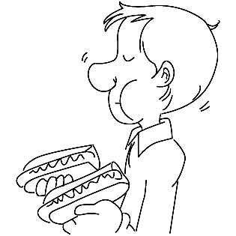
( ) 

五、Reading 20％

六、Speaking 20％

